**Chapter 1: INTRODUCTION**

**Topic – 1: Data In Business**

**Data Warehouse**

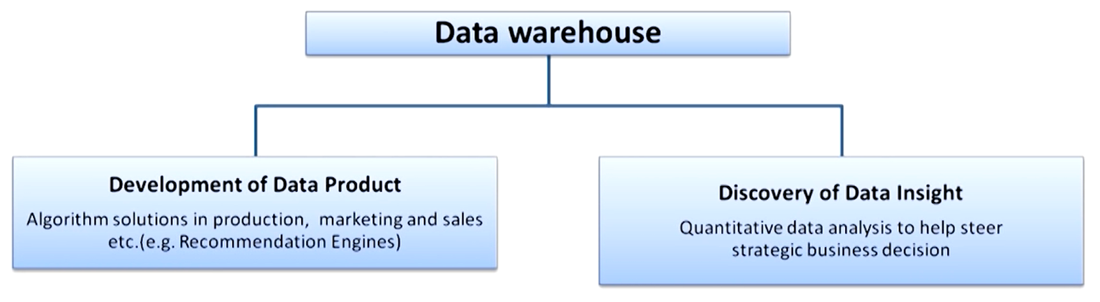

**Business Uses**

* Helps evaluate performance.
* Helps improve process.

**Topic – 2: About Data Analytics**

**Analysis v/s Analytics**

* **Analysis:** Studying & analysing about past.
* **Analytics:** Using past data to make use in future.

**Classification Of Data Analytics**

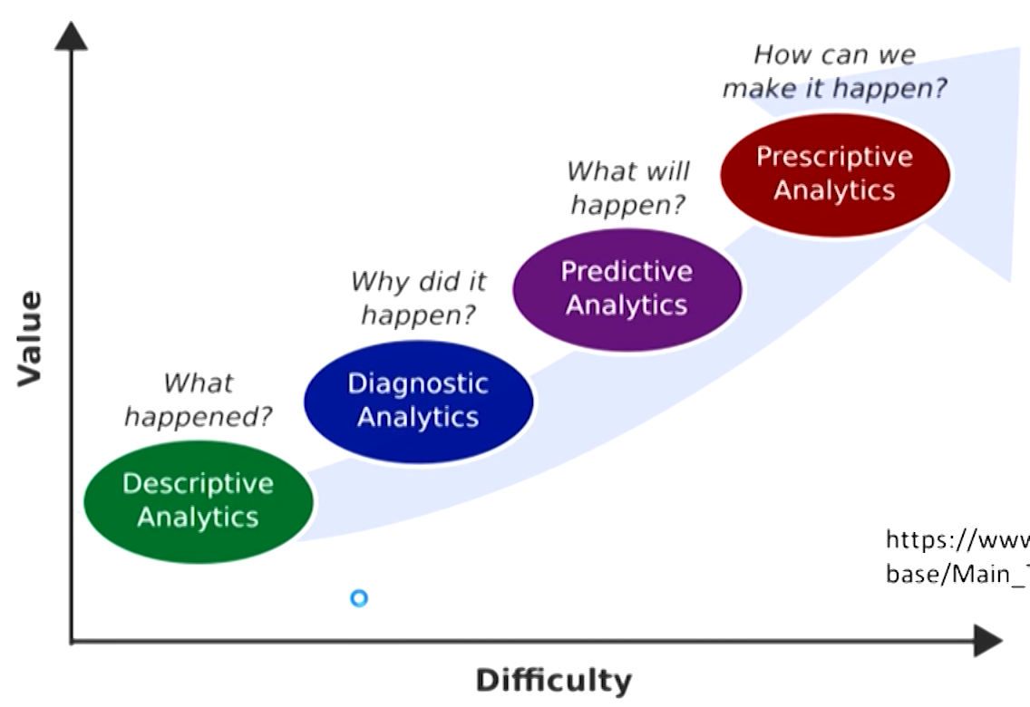

**Descriptive Analysis**

* Representing **summary** of data in form of **figures**.
* Data is prepared for further analysis.

**Diagnostic Analysis**

* **Digging** data and find out the **source** of the problem.

**Predictive Analysis**

* Forecasts predictions based on trends.
* Even includes predicting **when** something will happen.
* Data mining is one of the techniques used in predictive analysis.

**Prescriptive Analysis**

* Tells the best decisions to make.
* Tells how to optimize your actions.
* It uses simulations to know what action will be best.

**Data Scientist Skillset**

* Mathematics expertise
* Technology using skills
* Business & strategic mindset

**Topic – 3: Levels Of Data Measurement**

**Types Of Variables**

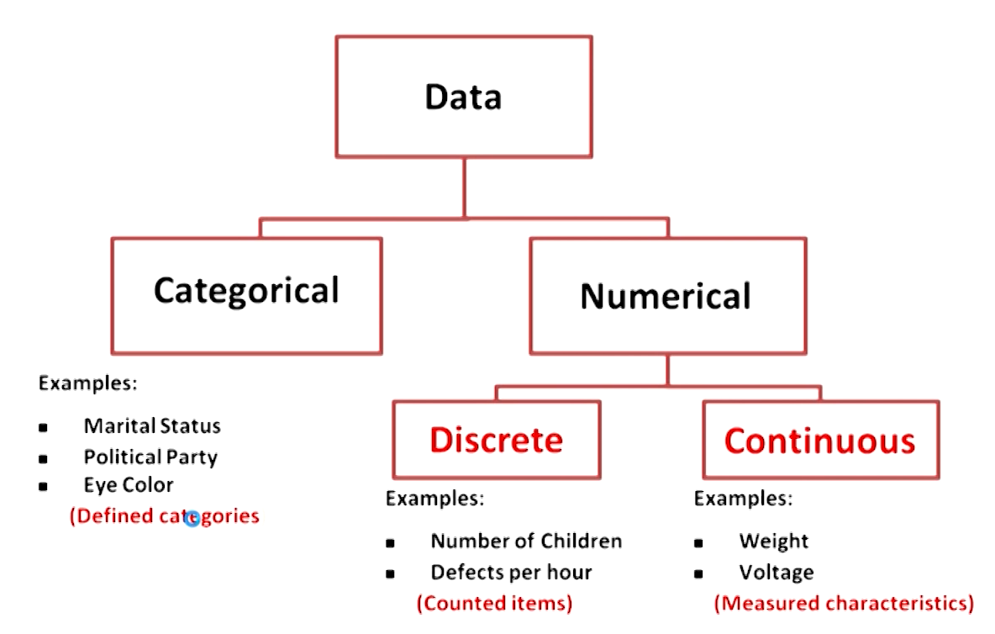

**Levels Of Data Measurement**

* **Nominal:** Classifies data into **categories** having **no ranking** among.
* **Ordinal:** Classifies data into **categories with ranking**.
* **Interval:** Measurement is taken in **quantity** & there is **no true zero point**.
* **Ratio:** Measurement is taken in **quantity** & there **is** a **true zero point**.